Getting the Basics of Correlation & Covariance

Correlation is one of the widely used statistical concepts. This blog post tries to answer what correlation is, why it is so helpful, what relationship correlation and covariance share and some of ways to calculate correlation.

**What is Correlation?**

Correlation, statistical technique which determines how one variables moves/changes in relation with the other variable. It gives us the idea about the degree of the relationship of the two variables. It’s a bi-variate analysis measure which describes the association between different variables. In most of the business it’s useful to express one subject in terms of its relationship with others.

For example: Sales might increase if lot of money is spent on product marketing.

**Why it is useful?**

1. If two variables are closely correlated, then we can predict one variable from the other.

2. Correlation plays a vital role in locating the important variables on which other variables depend.

3. It’s used as the foundation for various modeling techniques.

4. Proper correlation analysis leads to better understanding of data.

5. Correlation contribute towards the understanding of causal relationship(if any).

**Relationship of Correlation and Covariance**

Before diving more into correlation, let’s get the understanding of covariance.

**Covariance**: The prefix ‘Co’ defines some kind of joint action and variance refers to the change or variation. So it says, two variables are related based on how these variables change in relation with each other.

But wait, is covariance same as correlation?

As covariance says something on same lines as correlation, correlation takes a step further than covariance and also tells us about the strength of the relationship.

Both can be positive or negative. Covariance is positive if one increases other also increases and negative if one increases other decreases.

Covariance is calculated as

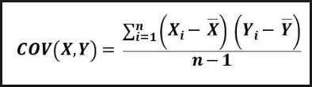

Covariance formula

Xᵢ= Observation point of variable X

x̅= Mean of all observations(X)

Yᵢ= Observation point of variable Y

ȳ = Mean of all observations(Y)

n= Number of observations

**Decoding the covariance formula:**Covariance between two variables x and y is the sum of the products of the differences of each item and their respective means divided by the number of items in the dataset minus one..

Getting better understanding with a simple example of sample data:

Following data shows the number of customers with their corresponding temperature.

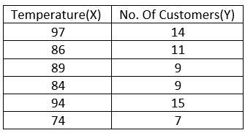

Example to understand correlation and covariance

First find means of both the variables, subtract each of the item with its respective mean and multiply it together as follows

Mean of X, x̅ = (97+86+89+84+94+74)/6 = 524/6= 87.333

Mean of Y, Ȳ = (14+11+9+9+15+7)/6 = 65/6= 10.833

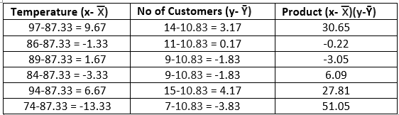

*COV*(*x, y*) = 112.33/(6–1) = 112.33/5 = 22.46

The covariance between the temperature and customers is 22.46. Since the covariance is positive, temperature and number of customers have a positive relationship. As temperature rises, so does the number of customers.

But here there is no information about how strong the relationship is, and that’s where correlation comes into the picture.

Correlation coefficient is the term used to refer the result of any correlation measurement methods.

So here, the sample Correlation coefficient is calculated as

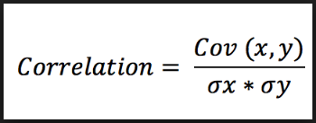

Correlation formula

*COV*(*x, y*) = covariance of the variables *x* and *y*  
 **σ***x* = sample standard deviation of variable *x*   
 **σ***y* = sample standard deviation of variable *y*

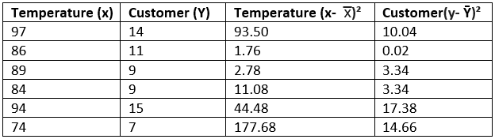

COV(x, y) = 22.46

σx = 331.28/5=66.25= 8.13

σy = 48.78/5=9.75=3.1

correlation = 22.46/(8.13x 3.1)= 22.46/25.20 =0.8

0.8 shows that strength of the correlation between temperature and number of customers is very strong.

Sample correlation coefficient can be used to estimate the population correlation coefficient.

Different methods exist to calculate correlation coefficient between two subjects. Some of the methods are:

**1.** **Pearson Correlation Coefficient**

It captures the strength and direction of the linear association between two continuous variables. It tries to draw the line of best fit through the data points of two variables. Pearson correlation coefficient indicates how far these data points are away from the line of best fit. The relationship is linear only when the change in one variable is proportional to the change in another variable.

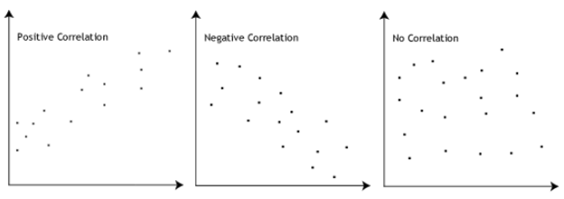

**Pearson Correlation Coefficient calculated as**

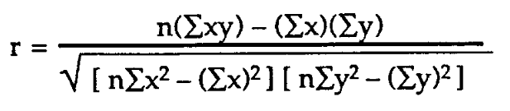

*r* = Pearson Correlation Coefficient

n = number of observations  
 ∑xy = sum of the products of x and y values  
 ∑x = sum of x values  
 ∑y = sum of y values  
 ∑x2= sum of squared x values  
 ∑y2= sum of squared y values

**Spearman’s Correlation Coefficient**

It tries to determine the strength and the direction of the monotonic relationship which exists between two ordinal or continuous variables. In a monotonic relationship two variables tend to change together but not with the constant rate. It’s calculated on the ranked values of the variables rather than on the raw data.

Monotonic and non- monotonic relationships are shown below:

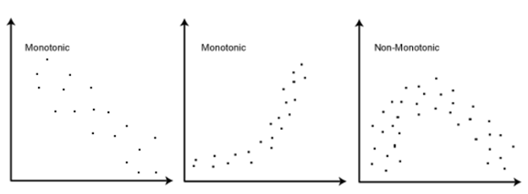

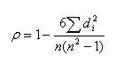

Spearman rank correlation coefficient

ρ= Spearman rank correlation coefficient  
di= the difference between the ranks of corresponding variables  
n= number of observations

**Comparison: Pearson and Spearman correlation coefficient**

Pearson and Spearman correlation coefficient can take values from -1 to 1.

**(i)**If one variable increases with the other variable at the consistent rate then Pearson coefficient would be 1, which results in a perfect line. In this case Spearman coefficient would also be 1.

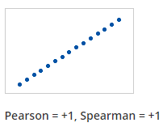

**(ii)**If one variable increases with the other variable but not with the consistent rate then Pearson coefficient would be positive but less than 1. In this case Spearman coefficient would be still 1.

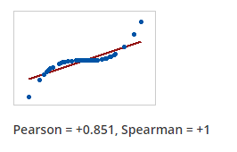

**(iii)**If the relationship is random then both the coefficients would be near 0.

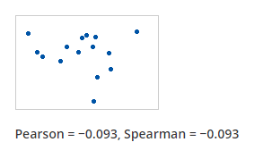

**(iv)**If the relationship between the variables is a perfect line but with a decreasing relationship then both the coefficients would be -1.

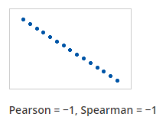

**(v)**If the relationship between two variables is such that one variable decreases when the other increases but not with the consistent rate, then Pearson coefficient would be negative but greater than -1. Spearman coefficient would be -1 in this case.

**When to use what?**

Pearson correlation describes linear relationships and spearman correlation describes monotonic relationships. A scatter plot would be helpful to visualize the data and understand which correlation coefficient should be used. Other way of doing is to apply both the methods and check which is performing well. For instance if results show spearman correlation coefficient is greater than Pearson coefficient, it means our data has monotonic relationships and not linear.

**Why correlation does not imply causation?**

Correlation and causation are terms which are mostly misunderstood and often used interchangeably. Understanding both the statistical terms is very important not only to make conclusions but more importantly, making correct conclusion at the end. In this blogpost we will understand why correlation does not imply causation.

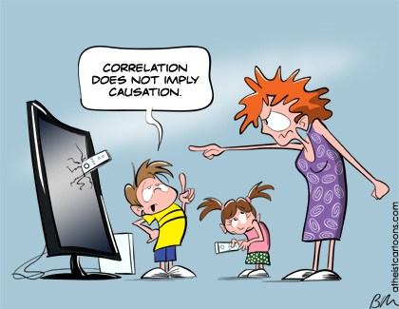

A lot of times we have heard “correlation does not cause causation” or “correlation does not imply causation” or “correlation is not causation”. But what they mean actually by saying this?

You will get a clear idea once we go through this blogpost. So let’s start!

### ****Getting the basics right****

**Correlation** is a statistical technique which tells us how strongly the pair of variables are linearly related and change together. It does not tell us why and how behind the relationship but it just says the relationship exists.

**Example:**Correlation between Ice cream sales and sunglasses sold.

As the sales of ice creams is increasing so do the sales of sunglasses.

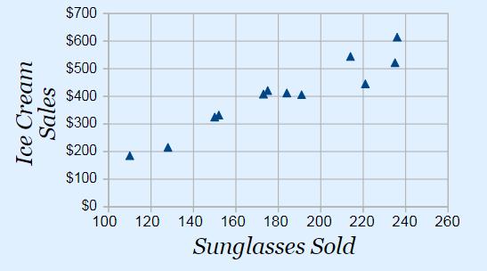

**Causation** takes a step further than correlation. It says any change in the value of one variable will **cause** a change in the value of another variable, which means one variable makes other to happen. It is also referred as cause and effect.



**Example:** When a person is exercising then the amount of calories burning goes up every minute. Former is causing latter to happen.

So now we know what correlation and causation is, it’s time to understand “Correlation does not imply causation!” with a famous example.

**Ice cream sales is correlated with homicides in New York (Study)**

As the sales of ice cream rise and fall, so do the number of homicides. Does the consumption of ice cream causing the death of the people?

No. Two things are correlated doesn’t mean one causes other.

**Correlation does not mean causality or in our example, ice cream is not causing the death of people.**



When 2 unrelated things tied together, so these can be either bound by causality or correlation.

In Majority of the cases correlation, are just because of the coincidences. Just because it seems like one factor is influencing the other, it doesn’t mean that it’s actually does.

Correlation is something which we think, when we can’t see under the covers. So the less the information we have the more we are forced to observe correlations. Similarly the more information we have the more transparent things will become and the more we will be able to see the actual casual relationships.

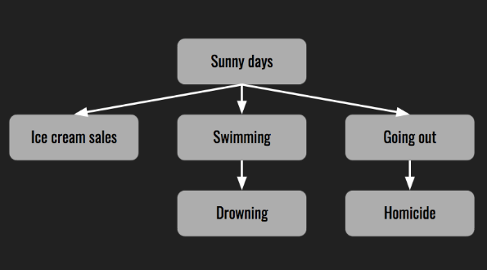

Relationship of sunny days with ice-cream sales and homicide

### ****Consider underlying factors before conclusion****

In some cases there are some hidden factors which are related on some level. Like in our example of ice cream sales and homicide rates , **weather** is the hidden factor which is causing both the things.Weather is actually causing the rise in ice cream sales and homicides. As in summer people usually go out, enjoy nice sunny day and chill themselves with ice creams. So when it’s sunny, wide range of people are outside and there is a wider selection of victims for predators.

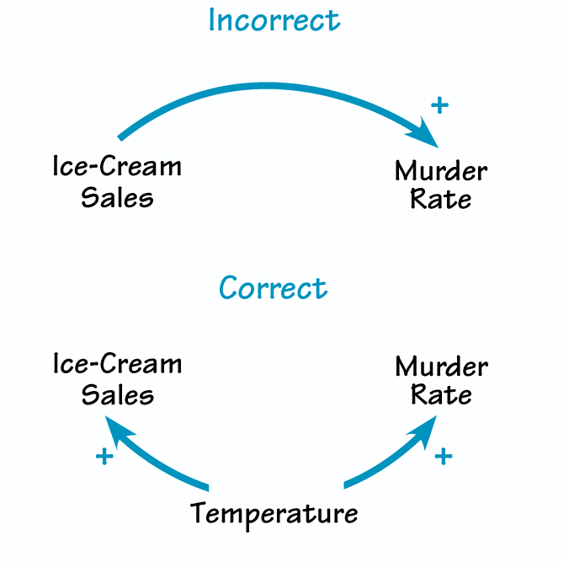

There is no causal relationship between the ice cream and rate of homicide, sunny weather is bringing both the factors together. And yes, ice cream sales and homicide has a causal relationship with weather.

### ****Don’t conclude too fast!****

Just after finding correlation, don’t draw the conclusion too quickly. Take time to find other underlying factors as correlation is just the first step. Find the hidden factors, verify if they are correct and then conclude.

Thanks for reading!!